Teacher Guide:
Pre-event activities

The pre-event activities are designed to last approximately 2 lessons. Both are designed to be teacher lead, but the personal discovery session can also be student led if desired.
The resources focus on understanding the local opportunities for careers and students’ personal strengths and skills and how this may align with certain jobs.
Resource Aims
- Students will go into the event with a clear action plan and understanding of local opportunities and development areas.
- Understand their own strengths and career interests
- Understand the format of the event.

Below please find a session overview for each of the resources and how they link to the journey log.
- Session 1: Opportunity Discovery
- Session 2: Personal Discovery

Session: | Opportunity Discovery
Age range: | KS3 – KS5 | Expected duration: | 45 – 60 minutes
Room requirements: | Standard room with projector and screen.  Internet and YouTube access for videos (not essential)
Learning objectives: | - Be aware of the local opportunities and career paths  - Make the most of your which way log.  - Understand the purpose of the which way careers fair
Skills builder links:
Gatsby Benchmark links: | 2. Learning from career and labour market information
Resources required: | Student Journey log – 1 per student  Opportunity Discovery PowerPoint presentation.
Activity 1 | Quiz |  | 25-35 minutes
The quiz introduces the different routes including further education, apprenticeships, and higher education along with several major employers in the region.
There are 10 questions in total. Please refer to the notes for future detail to expand the discussion around each question with the students. Some questions also have short videos linked to them.
Students should note their answers in their booklets.

Activity 2 | Code Breaker |  | 10-15 minutes
This quick code breaking challenge gives the students an opportunity to use their problem solving and teamwork skill. Highlight the importance of these skills and other transferable skills such as communication and leadership in all careers.

There is a different fact per region (so please hide slides you are not using). Each fact takes the form of a sentence where there are some words already given. They must then try and determine the code for the different symbols to uncover the fact.

Clue – all the header slides in the PowerPoint have the code icons on. These match to the heading for that slide.

Answers:
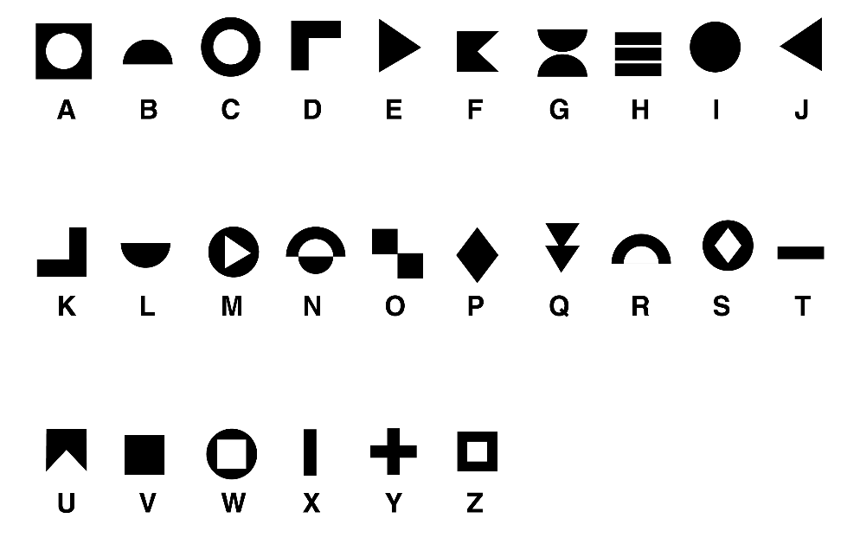

Dartmoor is the most important area for Bronze Age archaeology in western Europe.
South West Nucleus is the UK’s first nuclear industry cluster.
Brixham fishing port lands £36 million of fish.
HMND Devonport is the largest naval base in western Europe.

Activity 3 | The Careers Fair |  | 5 – 10 minutes
Please explain that the careers fair will be taking place on the 27th, 28th and 29th April.
The exhibition will be accessible from 9am on the first day.
Live sessions and informal Q+A slots will take place throughout the event.

Session: | Personal Discovery
Age range: | KS3 – KS5 | Expected duration: | 60 minutes +
Room requirements: | Standard room with projector and screen.  Access to mobile or computer device with the internet.
Learning objectives: | - Recognise and understand personal strengths, skills, values and ambitions  - Consider how these might link to possible careers and pathways
Skills builder links:
Gatsby Benchmark links: | 2. Learning from career and labour market information  3. Addressing the needs of each pupil
Resources required: | Student Journey log – 1 per student  Personal Discovery PowerPoint presentation.
Activity 1 | Personality quiz |  | 10 minutes
Students should access this quiz on a computer or mobile. It is very quick to complete (<5minues). https://icould.com/buzz-quiz/.
If this is being done in a class setting students should reflect on their results with a partner. Do they agree/ disagree? Students should then complete the quiz page in their booklet.

Activity 2 | SWOT |  | 20 minutes
Explain what SWOT stands for with the aid of the slides, first in an organisational context. Ideally pick a business the students are familiar with and ask them for some suggestions of the companies SWOT.

e.g. MacDonald’s:
Strengths – brand recognition, speed of delivery
Weaknesses – unhealthy food
Opportunity – new development e.g., housing, service station.
Threats – perceptions around poor quality, COVID

Then ask students to complete a personal SWOT analysis focusing on their own strengths and weaknesses, possible opportunities, and possible threats.

Activity 3 | Career Research |  | 20 minutes
Get students to pick three careers that interest them or that were suggested by the quiz. If they are still stuck offer some suggestion from the jobs slide.

They should then use a computer to find three job adverts for their chosen (or similar job) and complete a fact file for each.
At the end of the activity get them to feed back to the group about one of the jobs they found out about (ideally the one they are most interested in).

Activity 4 | SMART Target |  | 10 minutes
Based on everything they have learnt students should then set themselves one SMART target for the event (e.g. looking at x number of employers, joining a live session and interacting, finding out more about x sector) or their next step on their career journey (e.g. personal statements, searching for jobs, working towards key qualifications.

The PowerPoint notes provide future ideas and guidance around setting SMART targets.

